Ticket booking Application Requirement

**Main Index**

1. Sign Up
2. Sign In
3. Admin Portal
4. Client Portal
5. Booking

**Signup Page:**

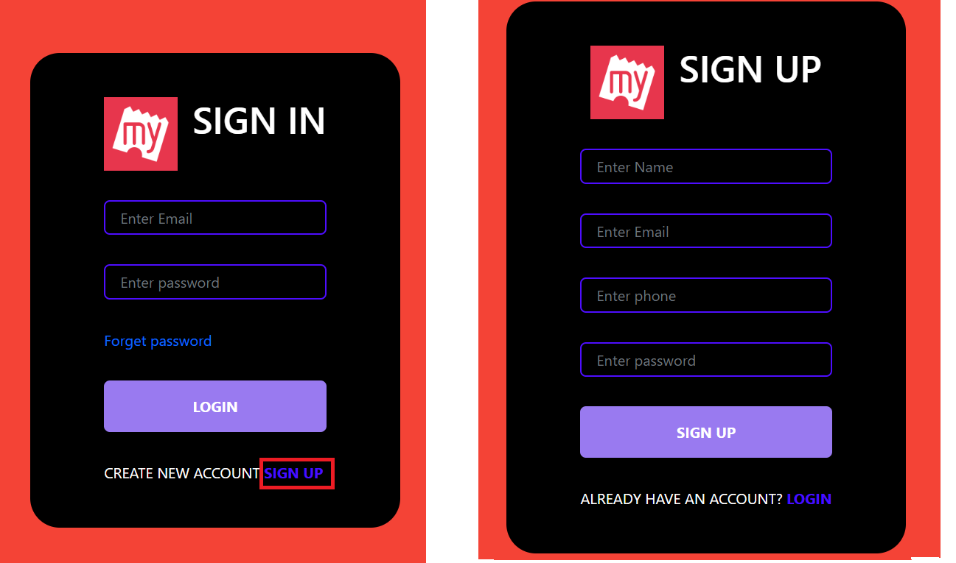

1. On the Sign In page click on “Sign up” link to register new client with details like “Name, Email, Mobile number, Password”
2. Verification link with validity of 5mins will be sent to respective user mail to verify the account
3. On the verification mail select “Click Here” link to verify the account
4. To generate new verification link user should enter email ID and Password in Sign in page
5. If client try to signup with existing user email ID then an error message as “” should get displayed

